1. **Write a Java program to create a class known as "BankAccount" with methods called deposit() and withdraw(). Create a subclass called SavingsAccount that overrides the withdraw() method to prevent withdrawals if the account balance falls below one hundred.**

**Answer:**

import java.util.*;

class BankAccount{

double balance;

BankAccount(double b){

balance = b;

}

void deposite(double amount){

if(amount>0){

balance += amount;

System.out.println("Deposited rupees" + amount);

} else{

System.out.println("Deposited amount must be positive");

}

}

void withdraw(double amount) {

if (amount > 0 && balance >= amount) {

balance -= amount;

System.out.println("Withdrawn rupees " + amount);

} else {

System.out.println("Insufficient balance or invalid amount");

}

}

void displayBalance(){

System.out.println("Current balance: " + balance);

}

}

class savingAccount extends BankAccount {

static double minBalance = 100;

savingAccount(double b){

super(b);

}

void withdrow(double amount){

if(balance - amount > minBalance){

super.withdraw(amount);

}

else{

System.out.println("minimum balance of rupees 100");

}

}

}

public class BankApp{

public static void main(String[] args) {

Scanner sc = new Scanner(System.in);

System.out.println("Enter initial balance");

double b = sc.nextDouble();

savingAccount SA = new savingAccount(b);

while(true){

System.out.println("\n1Deposite \n2.Withdrow \n3.Display Balance \4.Exit");

System.out.println("choose an option");

int choice = sc.nextInt();

switch(choice){

case 1:

System.out.println("Enter deposite Amount:");

double depositeA = sc.nextDouble();

SA.deposite(depositeA);

break;

case 2:

System.out.println("Enter withdrow Amount");

double wAmount = sc.nextDouble();

SA.withdrow(wAmount);

break;

case 3:

SA.displayBalance();

break;

case 4:

System.out.println("Exting");

return;

default:

System.out.println("invalid choice plase try again");

}

}

}

}

**Output:**

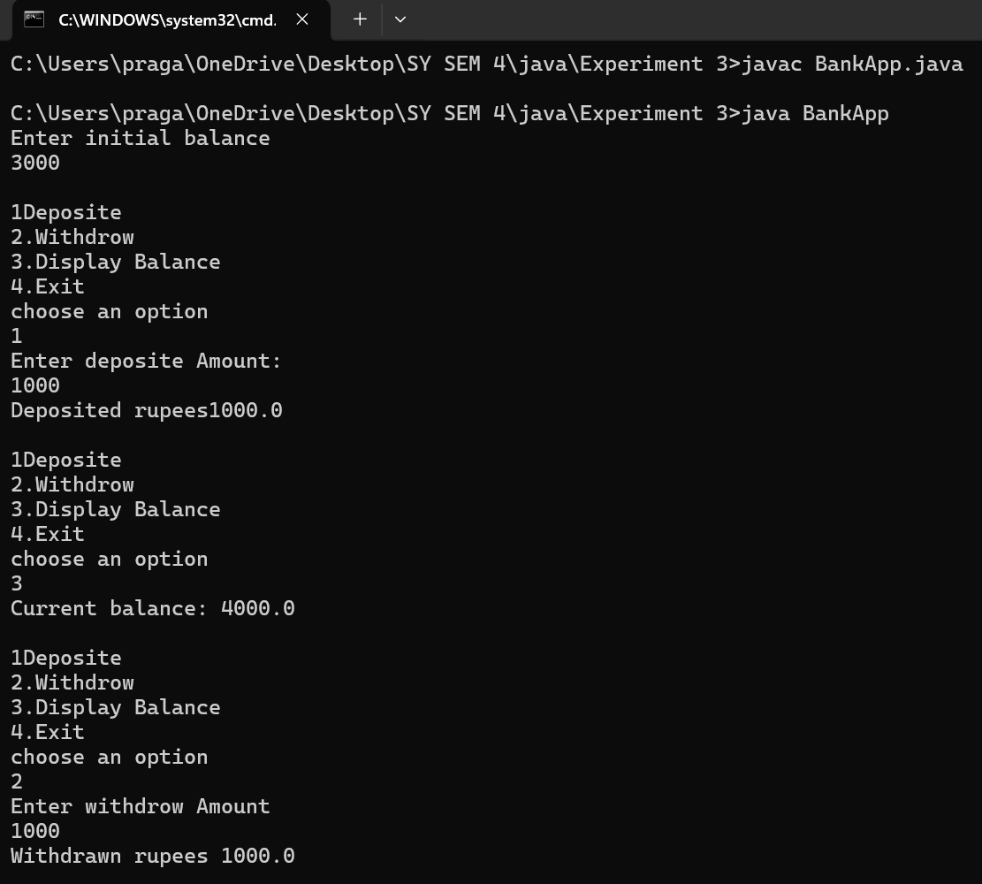

1. **Write a Java program that creates a class hierarchy for employees of a company. The base class should be Employee, with subclasses Manager, Developer, and Programmer. Each subclass should have properties such as name, address, salary, and job title. Implement methods for calculating bonuses, generating performance reports, and managing projects.**

**Answer:**

import java.util.Scanner;

class Employee {

protected String name;

protected String address;

protected double salary;

protected String jobTitle;

Employee(String name, String address, Double salary, String jobTitle){

this.name = name;

this.address = address ;

this.salary = salary;

this.jobTitle = jobTitle;

}

double calculateBonus(){

return salary*0.10;

}

void PerformanceReport(){

System.out.println("Performonce report for:" + name + " job title is:" + jobTitle);

}

void manageProject(){

System.out.println(name+":Managing Project");

}

}

class manager extends Employee{

manager(String name, String address, Double salary, String jobTitle){

super(name, address, salary, jobTitle);

}

double calculateBonus(){

return salary*0.20;

}

void PerformanceReport(){

System.out.println("Performonce report for:" + name + " job title is:" + jobTitle);

}

void manageProject(){

System.out.println("Manager"+name +"Managing Project");

}

}

class devloper extends Employee{

devloper(String name, String address, Double salary, String jobTitle){

super(name, address, salary, jobTitle);

}

double calculateBonus(){

return salary*0.15;

}

void PerformanceReport(){

System.out.println("Performonce report for:" + name + " job title is:" + jobTitle);

}

void manageProject(){

System.out.println("devloper"+name +"is working on devlopment task");

}

}

class programmer extends Employee{

programmer(String name, String address, Double salary, String jobTitle){

super(name, address, salary, jobTitle);

}

double calculateBonus(){

return salary*0.12;

}

void PerformanceReport(){

System.out.println("Performonce report for:" + name + " job title is:" + jobTitle);

}

void manageProject(){

System.out.println("Programer"+name +" is working on devlopment Program");

}

}

public class company {

public static void main(String[] args) {

Scanner sc = new Scanner(System.in);

System.out.println("Enter Manager information");

System.out.print("Enter manager name:");

String ManagerName = sc.nextLine();

System.out.print("Enter manager address:");

String address = sc.nextLine();

System.out.print("Enter manager salary:");

double ManagerSalary = sc.nextDouble();

sc.nextLine();

System.out.print("Enter your job title:");

String jobTitle1 = sc.nextLine();

sc.nextLine();

Employee manager = new Employee(ManagerName, address,ManagerSalary, jobTitle1);

System.out.println("Enter Devloper information");

System.out.print("Enter devloper name:");

String devloperName = sc.nextLine();

System.out.print("Enter devloper address:");

String devloperaddress = sc.nextLine();

System.out.print("Enter devloper salary:");

double devloperSalary = sc.nextDouble();

sc.nextLine();

System.out.print("Enter your job title:");

String jobTitle2 = sc.nextLine();

sc.nextLine();

Employee devloper = new Employee(devloperName, devloperaddress, devloperSalary, jobTitle2);

System.out.println("Enter Programmer information");

System.out.print("Enter programmer name:");

String programmerName = sc.nextLine();

System.out.print("Enter programmer address:");

String programmeraddress = sc.nextLine();

System.out.print("Enter programmer salary:");

double programmerSalary = sc.nextDouble();

sc.nextLine();

System.out.print("Enter your job title:");

String jobTitle3 = sc.nextLine();

sc.nextLine();

Employee programmer = new Employee(programmerName, programmeraddress, programmerSalary, jobTitle3);

System.out.println("\nGenerating Reports and Activities");

sc.nextLine();

manager.PerformanceReport();

System.out.println("Bonus is:"+manager.calculateBonus());

manager.manageProject();

sc.nextLine();

devloper.PerformanceReport();

System.out.println("Bonus is:"+devloper.calculateBonus());

devloper.manageProject();

sc.nextLine();

programmer.PerformanceReport();

System.out.println("Bonus is:"+programmer.calculateBonus());

programmer.manageProject();

sc.close();

}

**} Output:**

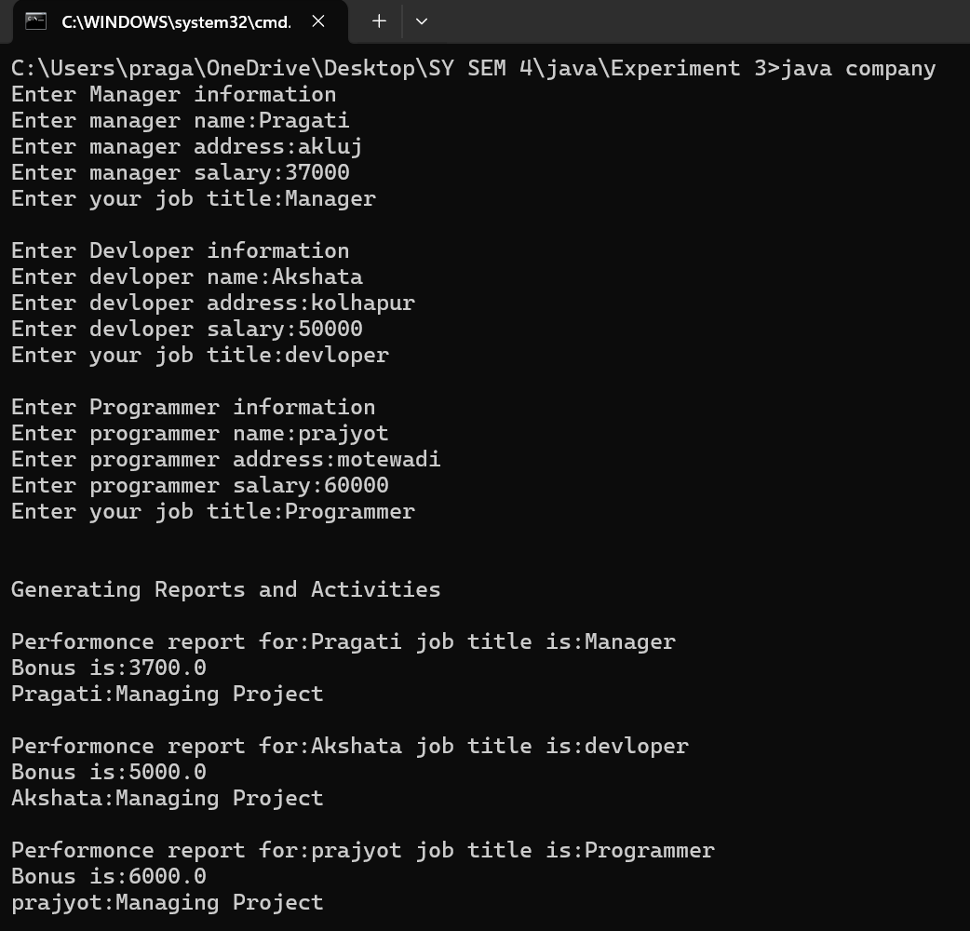

1. **Implement Following: a. Create abstract class shapes with dim1, dim2 variables and abstract area() method. Class b. rectangle and triangle inherits shape class. Calculate area of rectangle and triangle**.

**Answer**:

import java.util.Scanner;

abstract class shape{

protected double dim1, dim2;

shape(double dim1, double dim2){

this.dim1 = dim1;

this.dim2 = dim2;

}

abstract double Area();

}

class Rectangle extends shape{

Rectangle(double length, double width){

super(length, width);

}

double Area(){

return dim1*dim2;

}

}

class triangle extends shape{

triangle(double base, double height){

super(base, height);

}

double Area(){

return 0.5*dim1*dim2;

}

}

public class AreaCalculater {

public static void main(String[] args) {

Scanner sc = new Scanner(System.in);

System.out.println("Enter the length of rectangle");

double length = sc.nextDouble();

System.out.println("Enter the width of rectangle");

double width = sc.nextDouble();

Rectangle r = new Rectangle(length, width);

System.out.println("Area of rectangle" + r.Area());

System.out.println("Enter the base of triangle");

double base = sc.nextDouble();

System.out.println("Enter the height of traingle");

double height = sc.nextDouble();

triangle t = new triangle(base, height);

System.out.println("Area of Triangle is:"+ t.Area());

sc.close();

}

}

**Output:**

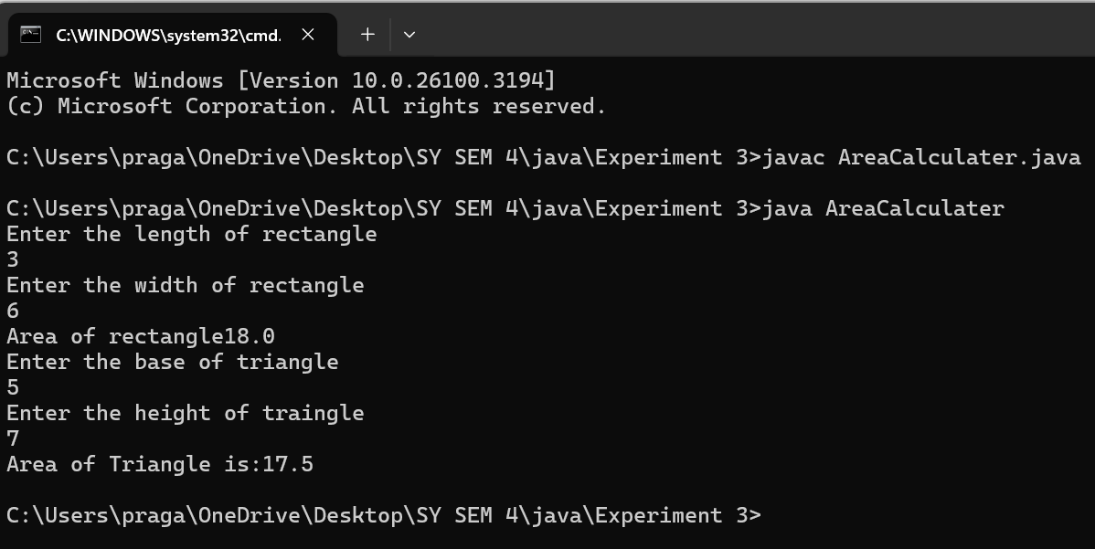

1. **Write a program to perform Multilevel Inheritance**

**Student(roll no)**

**Test(sub 1, sub 2)**

**Display result:**

**Answer:**

import java.util.Scanner;

class student{

int rollno;

void get_rollNo(int rollno){

this.rollno = rollno;

}

void displayRollno(){

System.out.println("Roll number is" +rollno);

}

}

class test extends student{

int sub1;

int sub2;

void getSubjectMark(int sub1, int sub2){

this.sub1=sub1;

this.sub2=sub2;

}

void DisplaySubjectMark(){

System.out.println("Marks of sub 1 is:" + sub1);

System.out.println("Marks of sub 2 is"+ sub2);

}

}

class result extends test{

void displayResult(){

int total = sub1+sub2;

displayRollno();

DisplaySubjectMark();

System.out.println("Total marks is" + total);

}

}

public class studentInheriatnce {

public static void main(String[] args) {

Scanner sc = new Scanner(System.in);

result r = new result();

System.out.print("Enter Roll No: ");

int roll = sc.nextInt();

r.get_rollNo(roll);

System.out.print("Enter marks of Subject 1: ");

int marks1 = sc.nextInt();

System.out.print("Enter marks of Subject 2: ");

int marks2 = sc.nextInt();

r.getSubjectMark(marks1, marks2);

r.displayResult();

sc.close();

}

}

**Output:**

